Fair Testing – paper helicopters

INSTRUCTIONS
Today we are going to:
- make paper (card) helicopters,
- test how long it remains in flight when thrown,
- change one variable of the helicopter (mass or length of rotor)
- investigate the effect of that change flight capabilities of the helicopter
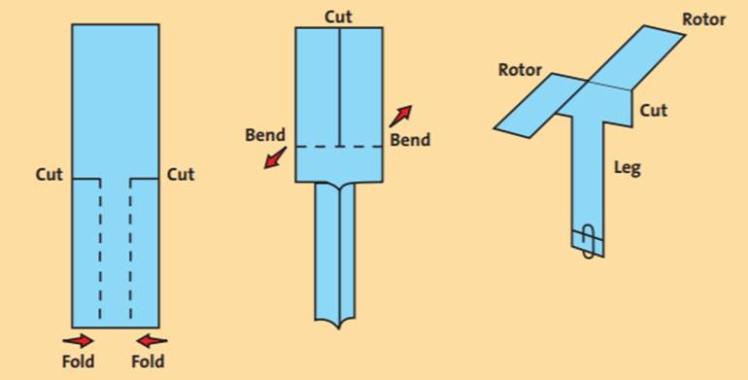
GUIDE ONLY – Your teacher will give you a template to cut out
  - Make your paper helicopter
- Cut out the helicopter template you have been provide by your teacher. It may be on paper or light cardboard. Cut along the solid lines and fold along the dotted lines until you have a shape like the one shown in the diagram below.
- Attach a paperclip to the bottom to provide some additional mass.

  - Throw the helicopter
- throwing can be done anyway really, but however the helicopter is throw it MUST BE A REPEATABLE action. For the duration of the experiment you should throw your helicopter exactly the same way (this is so you can control this variable).
- Time your helicopter from when you throw it to when it hits the ground. This is the flight time.

  - Record your data in the table in the results section
- Throw and measure the flight time of the helicopter five times. This provides five trials.
- Write each time in the table – you don’t need to include units as they are already listed in the table.
- Calculate the average flight time for your five trials.

  - Figure out what independent variable you will change in your helicopter.
- Simple independent variables would be the “length of the rotor” (you can cut them shorter and shorter), or “mass” (you can add paper clips or other mass).
- Write this independent variable in the heading of the first column of the table in the results. Include units (cm for rotor length or grams for mass)

  - Conduct the Experiment and record your data in the table below.
- You should try to vary the independent variable four times at least. Counting the data you have already collected this will give you five rows of data. This will give you five data points for the graph.

  - Graph the data you collected.
- Use the grid provided on the next page. Place the flight time (the averages column) on the vertical axis and your independent variable (the first column) on the vertical axis.
- Do a scatter plot. This is where you place a cross or dot for each data point. You should have five data points to place on the graph.

  - Draw a trend line for your data
- A trend line is either a straight line or a smooth curve which shows the patterns in the data

  - (OPTIONAL) Calculate the formula for the trend line by Calculating the slope and the y axis intercept.
- Calculate the slope using $slope= \frac{y_{2}- y_{1}}{x_{2}- x_{1}}$
- Identify the y axis intercept by extending the slope to the vertical axis
RESULTS
Table 1: Helicopter flight times

________________( )  (Independent variable) | Flight time (seconds)
 | Trial 1 | Trial 2 | Trial 3 | Trial 4 | Trial 5 | Average Flight Time  ($=\frac{sum of flight times}{5}$)

Analysis
Graph 1: Helicopter flight times.
_____________________Independent variable

_____________________Independent variable
Questions

  - Describe the relationship between the flight time and your independent variable.
Key points – this can be simple (as ……… increases, ……….. increases/decreases), or complicated where you use more detail and/or the terms linear, proportional, directly proportional, exponential). It can be the mathematical relationship to the straight line.

  - Which “treatment” resulted in the fastest decent time for your helicopter?

  - List each variable which you controlled (kept the same), and how you controlled it. (max of four)

  - Describe the amount of error in your results AND why you think there is this much error:
Key points – when you have a scatter plot you can tell how much error there is by how closely your data matches your trend line. If your data points are close to the trend line then your data forms a consistent pattern and is likely to have little error. You could also apply common sense and identify if your results seem logical and correct.

